Diabetes Collaborative Practice Agreement
Developed for Pharmacy Practice in the State of Colorado
[Prescriber/Prescriber Group] partnering with [Pharmacist/Pharmacist group]

- A. Policy Statement
A pharmacist is an integral part of the healthcare team, improving patient medication safety, adherence, and improving patient outcomes for chronic disease states. Collaborative Practice Agreements improve patient outcomes by allowing pharmacists to titrate, initiate, and monitor medications for chronic disease management. In collaboration, [Prescriber/Prescriber group etc.] and [pharmacist, pharmacist group, etc.] agree to employ this Collaborative Practice Agreement in accordance with Colorado Board of Pharmacy Regulations.

Per BOP Regulations “Collaborative pharmacy practice agreement,” or “collaborative practice agreement” (CPA), means a written and signed agreement entered into voluntarily between one or more Colorado-licensed pharmacists and one or more physicians or advanced practice nurses. A CPA grants authority to the pharmacist or pharmacists to provide evidence-based healthcare services to one or more patients pursuant to a specific treatment protocol. Either party may withdraw from an agreement at any time.

A pharmacist and prescriber entering into a Collaborative Practice Agreement must follow all rules and regulations as set out in in the State Board of Pharmacy Rules and Regulations 3CCR 719-1, section 17.00.00, Collaborative Pharmacy Practice.

This document is to serve as a guideline on collaborative practice for diabetes management, it is not intended to encompass all aspects of therapy management. Clinical judgment and consideration of individual patient characteristics should be included when making decisions regarding patient care.

B. Authority
- Pharmacists participating in collaborative practice will meet minimum competency requirements as outlined in Rule 17.00.30.
  - The pharmacist holds a current license to practice in Colorado;
  - The pharmacist is engaged in the practice of pharmacy;
  - The pharmacist has earned a Doctor of Pharmacy degree or completed at least five (5) years of experience as a licensed pharmacist
  - The pharmacist agrees to devote a portion of his or her practice to collaborative pharmacy practice;
  - There is a process in place for the physician, advanced practice registered nurse, and pharmacist to communicate and document changes to the patient’s medical record; and
  - The pharmacist carries adequate professional liability insurance in coverage of at least $1,000,000 per incident and at least $3,000,000 in aggregate.
- “Prescriber”, for the purpose of this Board Rule 17.00.00, means a physician who is actively and unconditionally licensed by the Colorado Medical Board or an advanced practice registered nurse with prescriptive authority who is actively and unconditionally licensed by the Colorado State Board of Nursing. The prescriber must have an established relationship with the patient or patients who will be served by the pharmacist(s) under the collaborative pharmacy practice agreement. Any Physician Assistant who may wish to participate in collaborative practice must do so under the authority of their supervising physician.
- The participating pharmacists and prescribers are listed at the end of this document.

C. Pharmacist Activities
- Prescriber and Pharmacist Interactions
  - The prescriber will “refer” a patient for Collaborative Practice services.
    - This “referral” constitutes an “order” per Colorado Rule 17
    - This referral may come in multiple forms. The following are considered a referral for Collaborative Practice Activities
      - A verbal order from the prescriber or prescriber’s delegate
      - A written order from the prescriber
      - A note in the chart requesting follow up with a pharmacist for CPA activities and sent via [fax, secure message, etc.] to the pharmacist.
  - All CPA visits will be documented via SOAP note and be communicated to the referring provider [available in a shared medical record, faxed, sent via secure messaging, etc.] within 24 hours. The notes will be signed by the pharmacist.
  - The pharmacist will clearly document medication changes
  - All orders/prescriptions will be written according to the current accepted medical standard and signed by the pharmacist, sent under the prescriber’s name.
  - Medication changes do not need to be approved by provider unless a specific CPA is not followed
  - The provider may override any decision made by the pharmacist
  - Urgent Communications
    - Allergic/Adverse Reactions: All adverse and allergic reactions will be clearly documented in a SOAP note. If urgent follow-up is clinically necessary, patient will be referred to an acute care provider either via primary care, urgent care, or the emergency room, depending on severity.
    - Patient with complaints or symptoms that fall outside Collaborative Practice will be referred to the primary care provider or ordering prescriber.
    - If suicidal ideation arises during the patient-pharmacist interaction, the pharmacist will refer patient to Colorado Crisis Services, 988.
- Scope of Practice: Pharmacists have full scope of practice to evaluate and treat all disease states listed in CPA protocol [Attachment A.] Pharmacists may start, stop, adjust any medication commonly used for the listed conditions, per guidelines. This includes laboratory testing for medication and disease state monitoring. The pharmacist may perform or review the following physical assessments: all vital signs, foot examinations as indicated.
- Patient and Pharmacist Interactions
  - Collaborative Practice may be addressed with the patient:
    - In-person via an individual or group visit
    - Via telephone (audio-only) visits
    - Via secure Electronic Medical Record Messaging system
    - Via secure video visits
  - It is the responsibility of the patient to follow-up with recommended medications, ordered labs, appointments and phone follow-ups and this information should be communicated to the patient. The pharmacist will make all reasonable attempts to continue a good working relationship with patient if there are missed appointments.
  - Patient Dismissal: Patients who are not engaged in treatment plans or who no-show appointments with the pharmacist may be referred to the initial prescriber who ordered the CPA. This may be done over-the-phone, via secure messaging, or via fax. Attempts to contact patient will also be documented in dismissal.
  - Discontinuation of Pharmacist CPA Services
    - When the patient meets their therapeutic goals, the patient will be referred back to the prescriber for continued treatment. (i.e, annual BP check, every 3-6 month A1C check, etc.)
    - This will be clearly documented in the pharmacist SOAP note.
    - A patient may be re-referred to pharmacist services in the future, if needed.
- Retention of Records (Rule 17.01.01-17.03.00)
  - CPA Agreements: Pharmacists shall maintain all records of collaborative pharmacy practice agreements, and have readily available for inspection by the Board or its inspectors at the location where evidence-based healthcare services are provided, the following:
    - The agreement and protocol entered into with prescriber(s)
    - Documentation reflecting pharmacist qualifications to participate in CPA
  - CPA Activities: All records of collaborative pharmacy agreements shall be retained for a minimum of three years from the last date of healthcare service. Such records shall be available for inspection by the patient, the prescriber or prescribers, the Board or its inspectors, or any other authorized local, state, or federal law enforcement or regulatory agency.
    - Records may be maintained in an alternative data retention system such as a data processing system or direct imaging system provided that:
      - The records maintained in the alternative system contain all of the information required on the manual record;
      - The data processing system is capable of producing a hard copy of the record upon the request of the Board, its representative, or of other authorized, local, state, or federal law enforcement or regulatory agencies;
      - A back-up is conducted of the data processing system every twenty-four hours; and
      - The records are immediately available for the previous two years.
  - Confidentiality: The pharmacist shall provide adequate security to prevent indiscriminate or unauthorized access to confidential records. If confidential health information is transmitted through a data communication device, the confidential health information may not be accessed or maintained by the operator of the data communication device unless specifically authorized to do so by the patient. All protected health information obtained and maintained, including that obtained from the physician or other providers, must be strictly controlled in accordance with the requirements of Health Insurance Portability and Accountability Act of 1996, and the HITECH Act of 2009, and other federal and state laws and rules.

Approval:

___________ _________________ _________________________
[Prescriber Signature] [Date]
___________ _________________ _________________________
[Pharmacist Signature] [Date]
Type 2 Diabetes Protocol

This protocol is based on current national evidenced based guidelines. Pharmacists will manage diabetes therapies in accordance with these accepted current guidelines and literature. Pharmacists may prescribe and dispense FDA approved medication(s) to eligible patients according to
indications and contraindications recommended in current guidelines from the American Diabetes Association (ADA) Standards of Care in Diabetes 2024:
https://diabetesjournals.org/care/issue/47/Supplement_1
and American Association of Clinical Endocrinology Comprehensive Type 2 Diabetes Management Algorithm 2023: https://www.endocrinepractice.org/article/S1530-891X(23)00034-4/fulltext

or subsequent updated published guidelines recognized as the national standard of practice.

As outlined in the CPA agreement, the pharmacist may start, stop, adjust any medication commonly used for diabetes, per current guidelines. This includes laboratory testing for medication and disease state monitoring. The scope of the agreement covers adult patients (≥18 years of age) with Type 2 diabetes who are not currently pregnant. This agreement does not cover treatment for common comorbid conditions (eg. dyslipidemia, hypertension, or albuminuria). Pharmacists may obtain verbal orders for therapy considerations as recommended by current guidelines if not covered by a separate CPA agreement (Eg: evidence-based statin therapy or ACE/ARB therapy.)

Disease Assessment:

Pharmacists will assess the current state of patient’s diabetes control. This includes, but is not limited to, evaluation of renal function, Hemoglobin A1C, blood pressure, and Body Mass Index (BMI). The pharmacist will also evaluate patients’ medication list, medication history (allergies, failures, intolerances), and lifestyle. Therapeutic treatment decisions will be made based on laboratory tests and patient goals of therapy.

Goals of Therapy
Table 1: Therapeutic Goals
A1c (%) | SMBG (mg/dL) |  | CGM Goals |  |  | Patient population
 | FBG | PPBG⁺ or Bedtime Glucose | Time in Range (70-180 mg/dL) | Time High (>180 mg/dL) | Time Low (<70 mg/dL)
<6.5 | <110 | <140 | >70% | <25% | <4% | Adults with short duration of diabetes, type 2 diabetes treated with lifestyle or metformin only, long life expectancy, no significant cardiovascular disease
<7.0 | 80-130 | <180 |  |  |  | Most non-pregnant adults
<7.5 | 90-130 | 90-150 |  |  |  | Older adults who are healthy (few coexisting chronic illnesses, intact cognitive and functional status)
<8.0 | 90-150 | 100-180 | >50% | <50% | <1% | Older adults and those with complex/intermediate (multiple coexisting chronic illnesses or 2+ instrumental ADL impairments or mild-to-moderate cognitive impairment); OR patients of any age with a history of severe hypoglycemia, limited life expectancy, advanced micro or macrovascular complications, extensive comorbid continues, or long-standing DM in whom the goal is difficult to achieve despite DSME
<8.5 | 100-180 | 110-200 |  |  |  | Very complex/poor health (LTC or end-stage chronic illness or moderate-to-severe cognitive impairment or 2+ ADL dependencies)

Disease Treatment:

Lifestyle Management
Table 2: Lifestyle Management
Smoking cessation | - Advise patients not to use cigarettes and other tobacco products or e-cigarettes
Nutrition | - Emphasize eating patterns containing nutrient-dense, high-quality foods with less focus on specific nutrients, for example DASH, Mediterranean, and plant-based diets  - Provide educational material on healthy eating, including MyPlate Method
Weight Management | - For obese individuals sustained weight loss ≥7% is optimal
Physical Activity | - Perform at least 150 min/week of moderate-intensity aerobic physical activity, spread over at least 3 days/week with ≤2 consecutive days without exercise  - In the absence of contraindications, encourage resistance training 2-3 times per week on nonconsecutive days
Alcohol Intake | - If adults with DM choose to use alcohol, they should limit intake to a moderate amount (≤1 drink per day for adult women and ≤2 drinks per day for adult men)  - They should take extra precautions to prevent hypoglycemia

Drug Therapy Management
If self-monitored blood glucose (SMBG), Continuous Glucose Monitoring (CGM), and/or A1C is not at goals outlined in Table 1, the pharmacist may initiate, adjust, or discontinue DM medications (Appendix A) based on patient characteristics and preferences. (See Figures 1 & 2.) Medications may be ordered with up to one year of refills to allow for flexibility with a patient’s prescription benefits. Pharmacists may prescribe Continuous Glucose Monitoring (CGM) and/or fingerstick glucose monitoring as appropriate. Pharmacists may order any appropriate laboratory monitoring for medications based on recommendations in the package inserts.

DM medications at subsequent visits should be initiated, adjusted within the standard dosage range, or discontinued to reach SMBG and/or A1c goals unless tolerability, inadequate response, medication and/or lifestyle adherence or non-adherence, cost, patient preference, or simplifying regimen are of concern.

Examples of recommended treatment algorithms are included at the end of this publication.

Follow Up & Laboratory Monitoring
Patient should follow up as recommended by the pharmacist and based on guidelines. Medication adjustments may occur after evaluating and documenting lab tests (eg A1c), SMBG or CGM values and evaluating for adverse effects and optimizing medication dosages.
Pharmacists may order all laboratory tests and perform physical assessments as outlined in this protocol. If results are within normal limits and/or stable, the pharmacist will document in their treatment note their plan. Abnormal, but not critical, laboratory and vital sign values will be expected and documented appropriately. If a laboratory value or vital sign is critical, as defined in this document, the pharmacist will make the appropriate decision to send patient to urgent care, emergency care, or follow-up with primary care provider within 2 weeks, or as appropriate.
Table 3: Assessments and Follow-Up
Test | Baseline | Follow-up | Critical Values
Hemoglobin A1C | All patients within 12 months | Above target: every 3-4 months  At target: every 3-6 months or as clinically indicated. | None
Serum creatinine  (as part of CMP) | All patients within 12 months | Annually and within 4 weeks following initiation/dosage titration of ACE-I/ARB or within 4 weeks of a significant change from baseline. | SCr change > 30%. Consult PCP if SCr increased by >0.3 mg/dl or is progressive.
Microalbumin/Cr | All patients within 12 months | Annually. May order repeat lab to confirm abnormal result. | N/A
LFTs  (as part of CMP) | All patients within 12 months if initiating pioglitazone therapy or statin. | Annually or within 6 months following initiation or titration of pioglitazone therapy. Only as clinically indicated for patients on statin therapy. | ALT or AST remains > 3 ULN
Lipid Profile | Within 12 months | Every 6-12 months if stable on medication. In 1-3 months to assess adherence | TG > 1000 mg/dL
Vitamin B12 | N/A | Annually for patients on metformin with neuropathy complaints | N/A; Consult PCP if abnormal within 2 weeks
Blood Pressure | All Patients | <130/80: Every 2-3 visits  >130/80: Every visit until at goal; Refer to PCP for visit within 2 weeks if <180/120 | >180/120 patient will be referred to urgent care or emergency department
Body Mass Index/Weight/Height | All Patients | Weight at every 8-12 weeks for patients on medications that alter weight.  Annually for all other patients. | N/A

Appendix A: Appropriate Medication Classes and Tips
All medications may be started at their usual starting dose per package inserts and evidence-based drug databases, based on patient-specific factors such as renal and liver function.
Biguanides
Examples: Metformin, Metformin ER
Contraindication: eGFR <30 mL/min/1.73m²
Efficacy: Intermediate-High
Weight: Neutral
ASCVD: Benefit (potential)
HF: neutral
Cost: Low
Hypoglycemia: No
DKD Progression: neutral
Sulfonylurea (SU)
Examples: Glipizide, Glimepiride
Precautions: hypoglycemia, weight gain, renal impairment
Efficacy: High
Weight: gain
ASCVD: neutral
HF: neutral
Hypoglycemia: Yes
Cost: Low
DKD Progression: neutral
Thiazolidinedione (TZD)
Example: Pioglitazaone
Contraindications: HF NYHA Class III-IV; LFTs > 2.5x ULN
Efficacy: High
Weight: gain
ASCVD: Benefit (potential)
HF: increased risk
Hypoglycemia: No
Cost: Low
DKD Progression: neutral
Benefit in NASH
Dipeptidyl Peptidase IV Inhibitors (DPP-IV Inhibitor)
Examples: Linagliptin,Sitagliptin
Efficacy: Intermediate
Weight: neutral
ASCVD: neutral
CHF: potential risk: saxagliptin, others neutral
Cost: high
Hypoglycemia: No
DKD Progression: Neutral
Risk of pancreatitis, joint pain

Glucagon-Like Peptide-1 Receptor Agonists (GLP-1 RAs)
Examples: Liraglutide, Dulaglutide, Semaglutide
Contraindications: personal or family history of medullary thyroid carcinoma (MTC); patients with multiple endocrine neoplasia syndrome type 2 (MEN2)
Efficacy: High to Very high
Weight: loss
ASCVD: Benefit (liraglutide, dulaglutide, and SQ semaglutide) others neutral
HF: neutral
Cost: high
Hypoglycemia: No
DKD Progression: most have benefit
BBW: thyroid c-cell tumors
GLP-1 RA/GIP Dual Agonist
Example: Tirzepatide
No renal dose adjustments
Monitor renal function when changing doses in pts with renal dysfunction or severe adverse GI reactions
GI side effects temporary in nature
Efficacy: Very High
Weight: loss (very high)
ASCVD: unknown
HF: unknown
Cost: high
DKD Progression: unknown
Hypoglycemia: No
Sodium-Glucose Co-Transporter 2 (SGLT2) Inhibitors
Examples: canagliflozin, empagliflozin, dapagliflozin
Dose adjustments needed for renal dysfunction (See package inserts)
Efficacy: intermediate to high
Hypoglycemia: No
Weight: loss
ASCVD: Benefit (all, except ertuglifozin)
HF: Benefit
Cost: High
DKD Progression: Benefit (all, except ertuglifozin)

Insulins
Basal Insulins
Examples: Glargine, Degludec, concentrated glargine, Insulin NPH
Generally Start with A1C >9-10%
Starting dose for most patients: 0.1-0.2 units/kg/day
If reaching >0.5 units/kg/day, consider addition of mealtime insulin
Some better used twice daily (eg, NPH)
Combination or Mixed Insulins
Examples: Humulin 70/30, Novolin 70/30, Humalog 75/25, etc.
Usually dosed with meals, twice per day
Used to decrease Injection burden on patients on basal-bolus insulin.
Combination Basal Insulin/GLP-1 Products
Examples: Xultophy 100/3.6, Soliqua 100/33
Follow Package Inserts for dosing and precautions
Meal-Time or Bolus Insulins
Examples: Humulin R, Novolin R, Lispro, aspart, Afrezza
Different products have different onset of action, slightly different duration of action
Starting dose is typically 10% of basal dose or 4 units with the largest meal each day.
Figure 1: Medication Treatment for Type 2 Diabetes (ADA Standards of Care 2024)
References
- American Diabetes Association Professional Practice Committee: Standards of Care in Diabetes—2024. Diabetes Care 1 January 2024; 47 (Supplement_1): S1–S4. https://doi.org/10.2337/dc24-SINT
- American Association of Clinical Endocrinology Consensus Statement: Comprehensive Type 2 Diabetes Management Algorithm – 2023 Update. AACE CONSENSUS STATEMENT| VOLUME 29, ISSUE 5, P305-340, MAY 2023. DOI: https://doi.org/10.1016/j.eprac.2023.02.001

Reprinted with permission from The American Diabetes Association. Copyright 2024 by the
American Diabetes Association.

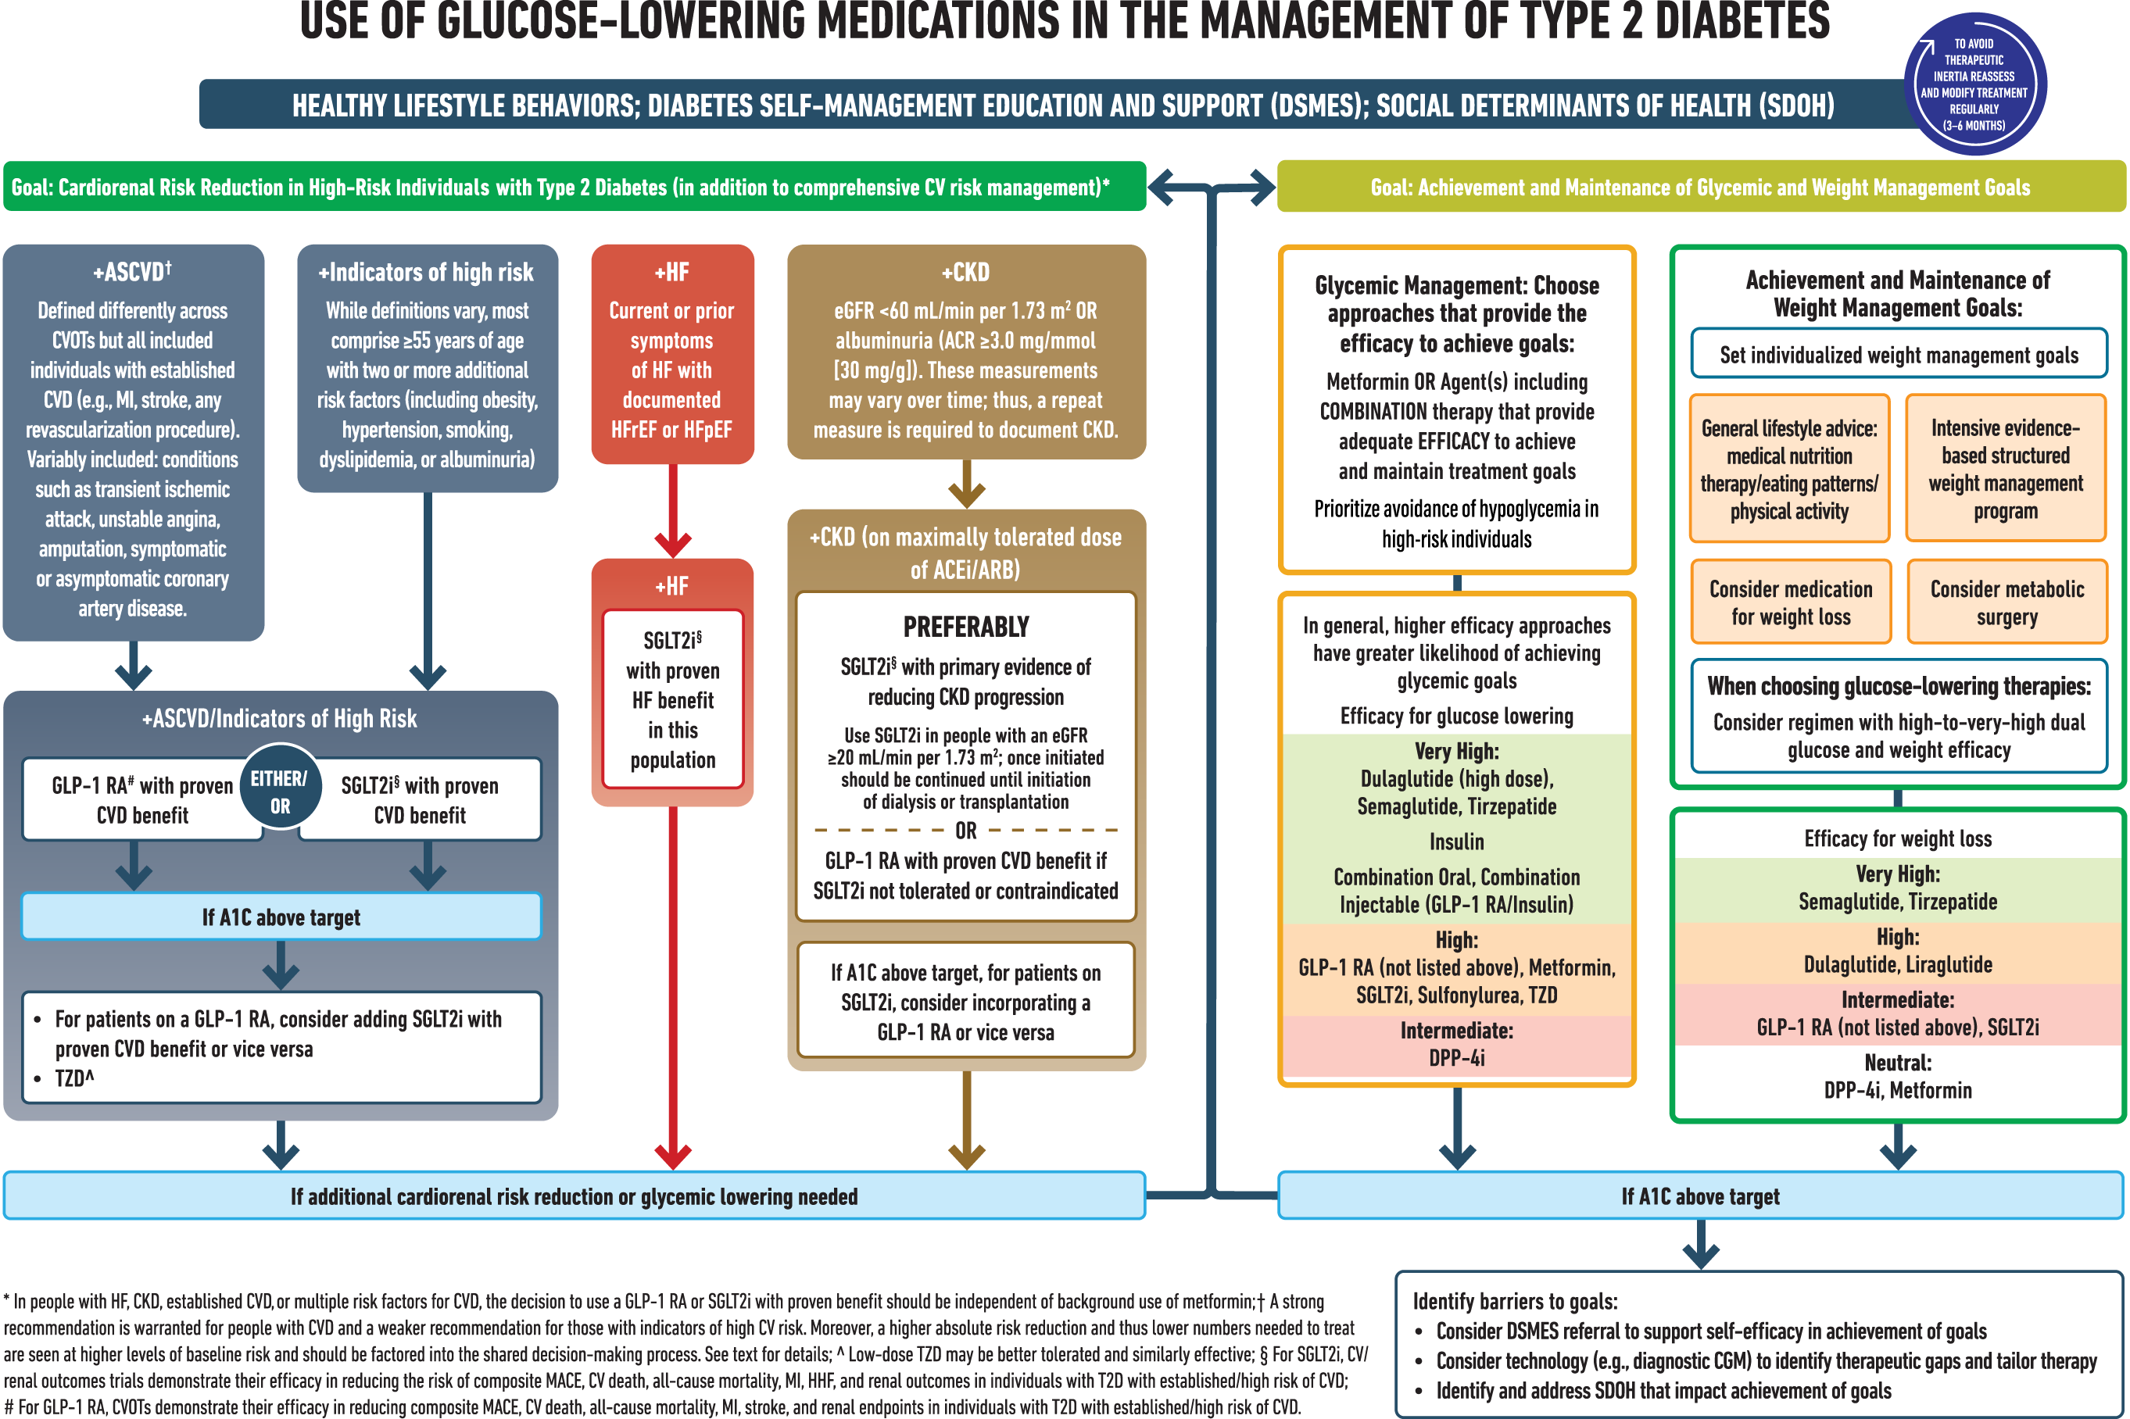
Figure 2: Insulin Titration (ADA Standards of Care 2024)
Reprinted with permission from The American Diabetes Association. Copyright 2024 by the
American Diabetes Association.
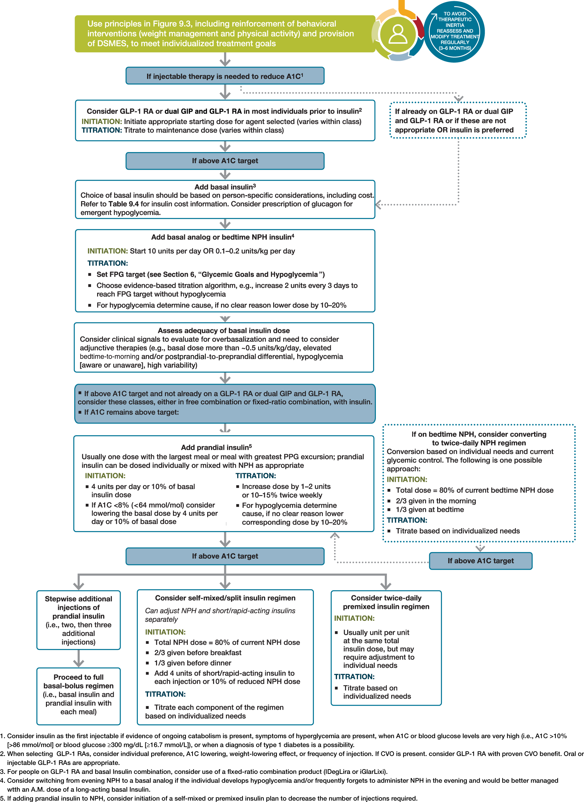tion.
Example SOAP Notes for Diabetes Visit
Initial Visit Template
Subjective: Patient presents for Initial PharmD DM Visit. Visit is over the phone/In-person. Patient was referred by [provider] for an A1C of X% on x/x/x, with/without albuminuria. Lipid panel shows x, egfr x. [List other known diabetes complications]
- Patient has had DM for xx years. Over these years they have learns xxx about diabetes. They are/are not familiar with their A1C. They can/cannot explain long-term complications of diabetes. They are/are not familiar with a healthy diet and exercise routine for diabetes.
- Baseline DM Knowledge:
- Current medications:
- Adherence:
- SMBG:
- Food Choices:
- Physical Activity:
- Stress: Present/absent
- Personal beliefs about diabetes (eg.; fear of insulin, cultural beliefs, etc. that may come up
- Patient Motivation for improving DM control:

Objective: Blood Pressure, Previous labs as applicable (A1C, Renal Function, Lipids, etc.)
Assessment:
- Patients A1C is above goal of <{7%, 8%, etc}
- SMBG or CGM reveals: FBG at goal/PPBG at goal, etc.
- Contributing factors include:
- Treatment options discussed include:

Plan:
- Today we will make the following changes:
- Education and encouragement provided.
- Follow-up scheduled:
- A large percentage of today's visit was focused around DM2 initial education including: explanation of current lab results, goals of therapy, importance of SMBG, micro/macrovascular complications of DM2 when BG not at goal, importance of taking prescribed medications daily, portion control, exercise recommendations, and need for continued f/u to assist with BG management. Discussed increase in veggies, some exercise is better than no exercise. Encourage pt to make small changes over time. Patient verbalizes understanding, and all questions were answered to patient satisfaction.
- Note sent to XXX via XXX.

Follow-Up Visit Template
Subjective: Patient presents for in person/telephone DM FUV. At last visit [x weeks ago] we [made no changes, increase x medication, etc.] Most recent A1C was XX on XX.
- Today patient reports home BG as follows:
  - SMBG- Done x times per week
FBG:
PM BG:
  - [Insert CGM data if applicable]
- Denies/Claims hypoglycemia, other adverse effects of medication
- Adherence: Reports X missed doses of medication over the last 2 weeks
- Biggest DM concern today:
- Physical Activity:
- Diet changes:
- Stress:
- Motivation for improving DM control:

Objective: Blood Pressure, Previous labs as applicable (A1C, Renal Function, Lipids, etc.)

Assessment:
- Patients A1C is above goal of <{7%, 8%, etc}
- SMBG or CGM reveals:
- Contributing factors include:
- Treatment options discussed include:

Plan:
- Today we will make the following changes:
- Education and encouragement provided.
- Follow-up scheduled:
- Note sent to XXX via XXX.

